Building a smarter AI-powered spam classifier

Phase 2

INNOVATION

Introduction:-

For the majority of internet users, email has become the most often utilized formal communication channel. In recent years, there has been a surge in email usage, which has exacerbated the problems presented by spam emails, Spam, often known as junk email, is the of sending mass messages to a large number of people. 'Hom' refers to emails that are meaningful but of a different type. Every day, the average email user receives. roughly 40-50 emails, spammers earn roughly million dollars per year from spam, resulting in financial damages on both a personal and institutional level. As a result, consumers devote a large amount of their working time to these emails. Spam is said to account for more than half of all email server traffic, sending out a vast volume of undesired and uninvited bulk emails They squander user resources on useless output, lowering productivity. Spammers use spam for marketing goals spread malicious criminal acts such as identity theft, financial disruptions, stealing sensitive information,

The existing model of the system: -

Spam refers to the term, which is related to Undesired content with low-quality Information. Spam referred to the major drawback of mobile business. When comes to spam detection in the campus network they did the analysis using Incremental Leaming. For Collecting Spam detection on web pages. Moreover Sending out a spam message was also analyzed Data Collection was done privately by a limited company. From the data Collection

. There also anti-spam filter system was evolved. Many parallel and distributed computing system has also processed this As we look at spam detection systems that use Machine Leaming (ML) techniques, it's vital to lake a look at the history of ML in the field as well as the many methods that are now used to spom. Researchers have discovered As a result the tactics that are currently effective may become obsolete in the near future.

The conceptual drill [B] is a term used to describe this occurrence. Machine Learning is an engineering approach that allows computational instruments to behove without being explicitly Because of the ML system's ability to evolve, limiting concept drift, this strategy is a significant help in detecting and combating spam. In section, we'll go through a variety of

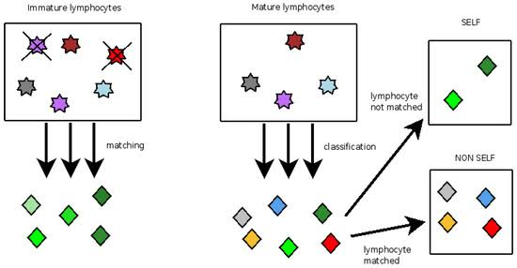

Proposed model of the system: -

As we look at spam detection systems that use Machine Learning (ML) techniques, it's vital to take a look at the history of ML in the field as well as the many methods that are now used to identify spam. Researchers have discovered that the content of spam emails, as well as their operational procedures, evolve with time. As a result, the tactics that are currently effective may become obsolete in the near future. The conceptual drift [8] is a term used to describe this occurrence. Machine Learning is an engineering approach that allows computational instruments to behave without being explicitly programmed. Because of the ML system's ability to evolve, limiting concept drift, this strategy is a significant help in detecting and combating spam

Load and simplify the dataset

Our SMS text messages dataset has columns if you read it in pandas: v1 (containing the class labels ham/spam for each text message), v2 (containing the text messages themselves), and three Unnamed columns which have use. We'll rename the v1 and v2 columns to class_label and message respectively while getting rid of the rest of the columns.

import pandas as pd df =

df.rename (columns =

pd.read_csv(r'spam.csv', encod ing="ISO-8859-1') {'vl': 'class_label', 'v2': 'message'}, inplace True) axis = 1, inplace=True) =

df.drop(['Unnamed: 2', 'Unnamed: 3', 'Unnamed: 4'],

df

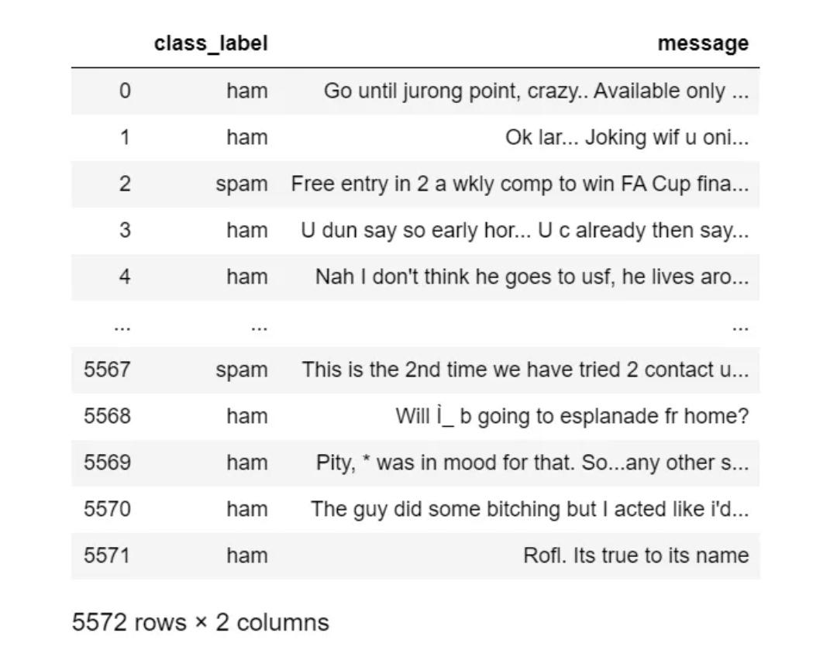

Explore the dataset:

Bar Chart It's a good idea to carry out some Exploratory Data Analysis (EDA) in a classification problem to visualize, get some information out of, or find any issues with your data before you start working with it. We'll look at how many spam/ham messages we have and create a bar chart for it.

#exploring the dataset df['class_label'].value_count

s()

Our dataset has 4825 ham messages and 747 spam messages. This is an imbalanced dataset; the number of ham messages is much higher than those of spam! This can potentially cause our model to be biased. To fix this, we could resample our data to get an equal number of spam/ham messages.

To generate bar chart, we use NumPy and pyplot from Matplotlib.

Conclusion: -

Following a thorough examination of the chosen study, Several study findings and observations have been identified as a result of our studies. These were previously discussed in detail.

portions that are well-explained In this section, we'll talk about concentrating more on the major findings and conclusions of the research Supervised machine learning has a high acceptance rate. Throughout the review, the approach can be noticed. This strategy is effective. is employed primarily because it produces more accurate findings. With less fluctuation, this strategy has a high level of consistency. Aside from that, we've discovered that certain algorithms work better than others. When compared to other techniques, such as Nave Based and SVM, there is a strong demand for them. Machine Learning Algorithms that aren't as well-known. The employed multi-algorithm. n order to achieve a better result, systems are increasingly commonly used. rather than a single algorithm